GitHub and Digital Repository Management- final project
IN-MEXICO PROGRAM BACKEND DEVELOPER CERTIFICATION

Valeria Anel Duque Salgado
16/09/2025
NAO ID: 3306

Contents:
BACKLOG 2
GITHUB ACCOUNT CREATION: 4
GIT INSTALLATION: 5
1. DOWNLOAD THE GIT SETUP FILES: 5
2. VERIFICATION: 7
S S H K E Y G E N E R AT I O N A N D C O N F I G U R AT I O N : 8
3. CREATION OF A SSH KEY ON GITBASH: 8
4. CONNECT GIT BASH WITH GITHUB: 8
5. VERIFY ON GITBASH: 10
REPOSITORY CREATION IN GITHUB AND PROJECT UPLOAD: 12
1. Repository creation: 12
2. Repository connection with local repository: 13
PROJECT UPLOAD: 14
NEW BRANCH CREATION : 15
1. Update to the requirements.txt file: 15
CREATED PR : 16
PR APPROVAL IN GITHUB: 18
1. Creation of branch "A" from "Main": 19
2. Creation of docs.txt in branch "A": 19
3. PR created for branch "A": 20
Creation of branch "B" from "Main": 21
4. Creation of a different docs.txt in branch "B": 21
5. PR created for branch "B": 23
CONFLICT BETWEEN BRANCHES: 24
CONFLICT RESOLUTION PROCESS: 25
GIT COMMAND USED TO REVERT CHANGES: 25
APPROVED PRS AND MERGED BRANCHES: 26
6. Pull request the other branch: 27

BACKLOG

GITHUB ACCOUNT CREATION:


Go to https://github.com/ and click on Sign Up:

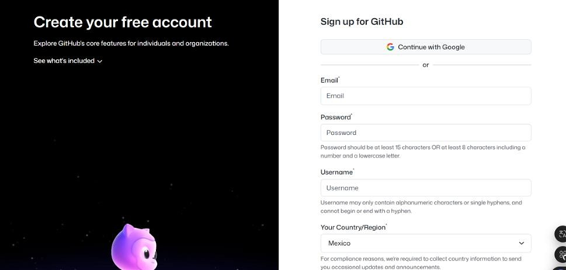
Then you can create an account through Google or with an email:

Once filled the information spaces and submitted the necessary information, the page will lead you to your new account:

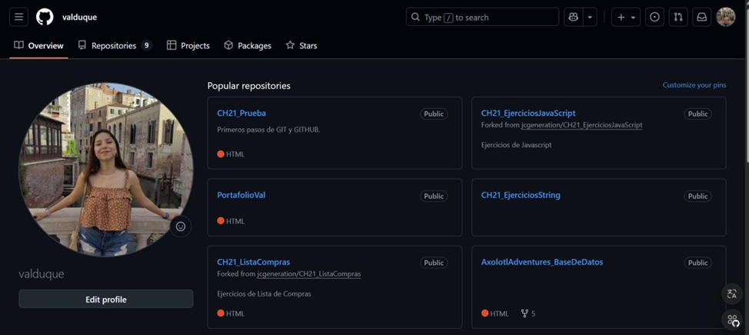

GIT INSTALLATION:

1. DOWNLOAD THE GIT SETUP FILES:

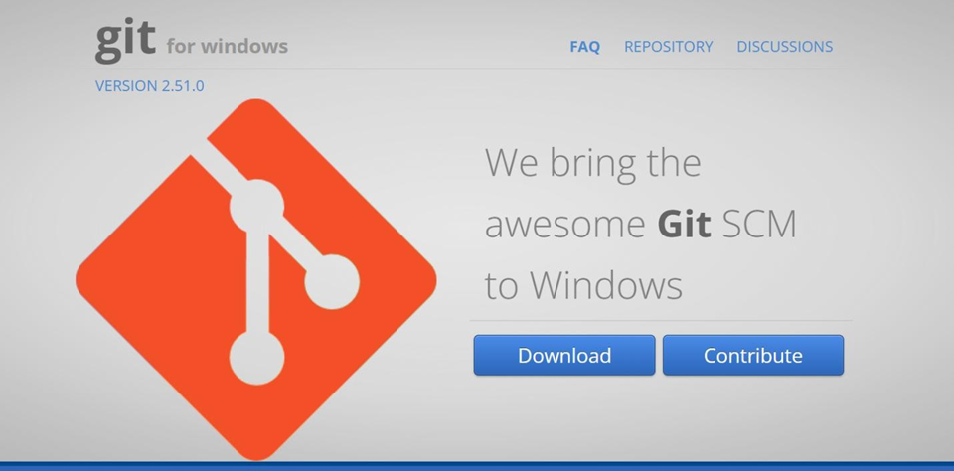
Go to the Git for Windows page (https://gitforwindows.org/) and download the setup files:

Once downloaded, start the installation and grant the corresponding permission:
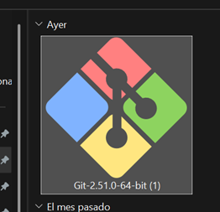

Start the installation system and select the Destination Location:
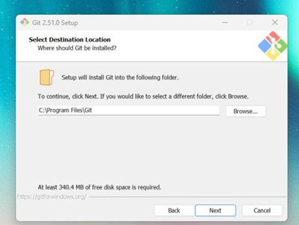
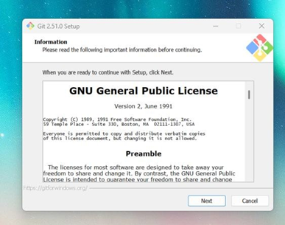

Select your installation preferences and let it install itself:
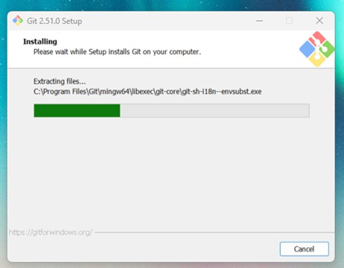

Finish the installation process:
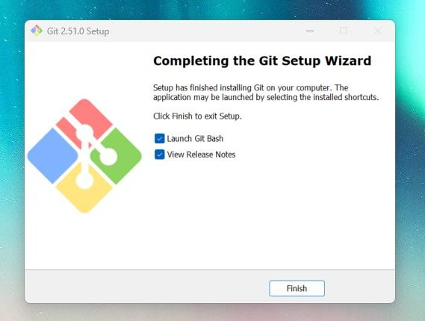

2. VERIFICATION:

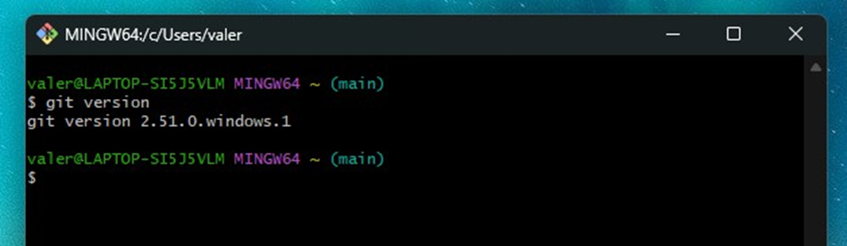
Open Git Bash and write down “git version” on the terminal to make sure everything is correct:

S S H K E Y G E N E R AT I O N A N D C O N F I G U R AT I O N :

3. CREATION OF A SSH KEY ON GITBASH:

Open GitBash and execute the command ssh-keygen -t ed25519 -C your_email@example.com, and replace the email example with your own email:
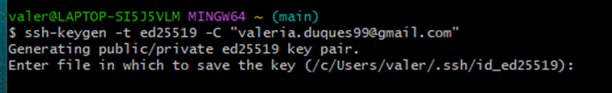
The system asks for a file to save the key, if you want to accept the default location of the key just press “enter”:
If it already exists, you can override it:

Then it must be added a passphrase. And enter the same passphrase again for confirmation:

If everything is set up correctly, this is a message you shall receive:

4. CONNECT GIT BASH WITH GITHUB:
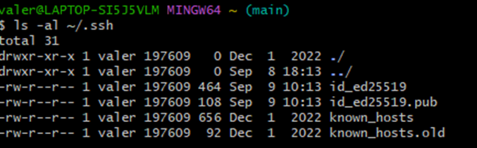
Write down on GitBash this command ls -al ~/.ssh, this is the outcome:

We need the one ending with .pub , then we write the command
cat ~/.ssh/id_rsa.pub, or in this case; cat ~/.ssh/id_ed25519.pub.
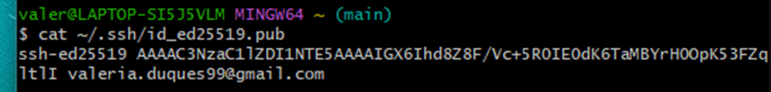
This is the outcome:

Full code is needed. It must be copied.
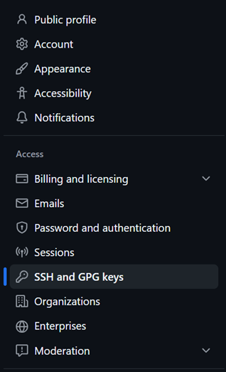
Then, we go to GitHub → Settings → SSH and GPG keys:

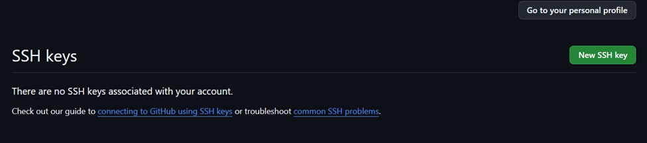
Click on “New SSH Key”:

After that, a ssh key creation page opens. The information must be filled up.
The key created on GitBash and previously copied will be placed in the last section of the page:

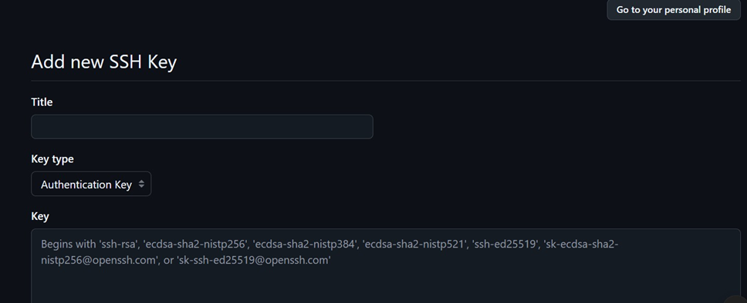
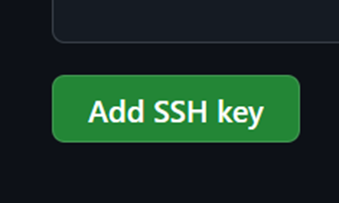
Once everything is done, click on “Add SSH Key” button:

Remember that your code must include email as well. If everything is correct, this message will appear:


5. VERIFY ON GITBASH:

To verify the connection with the account, write on GitBash the next command: ssh -T git@github.com
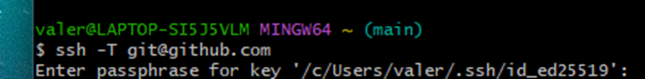
GitBash Will ask you for your passphrase, previously created:
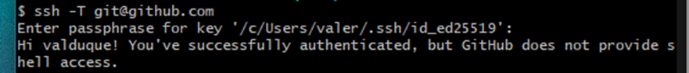
If it is connected, this message will appear:

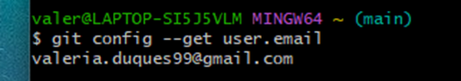
Can also be checked, by adding the command the “git config --get user.email” onto GitBash:

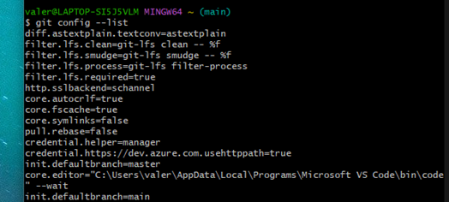
Or, can write the command “git config –list”, which will bring the full list of the GitBash configuration:

REPOSITORY CREATION IN GITHUB AND PROJECT UPLOAD:

1. Repository creation:
Inside the GitHub account, we must go to https://github.com/new . So, we can customize our repository:
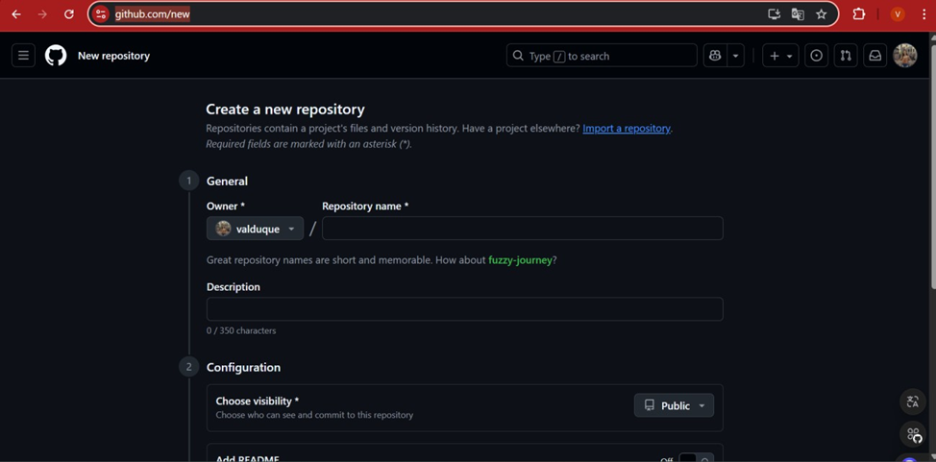

After that, just click the “Create repository” button:

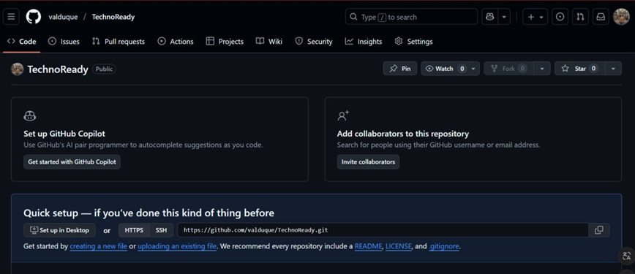
And now you can see your repository’s page:


Also, it’ll appear on your repositories’ list:

2. Repository connection with local repository:

From the local repository, GitBash must be open and initialize with the “git init”
command:

Then add the command “git init add origin” followed by the URL of you GitHub
repository:

PROJECT UPLOAD:
Inside our repository, and once our git is initiated, git execute de git add command, this will send all our files to the staging area:

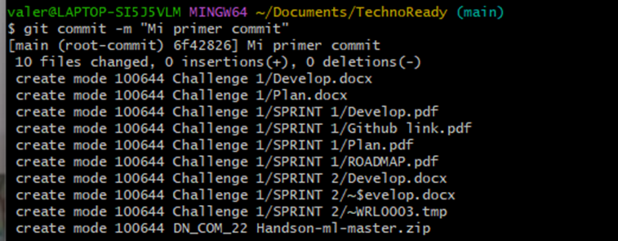
Then, we create a commit with the git commit -m “message” and press enter:

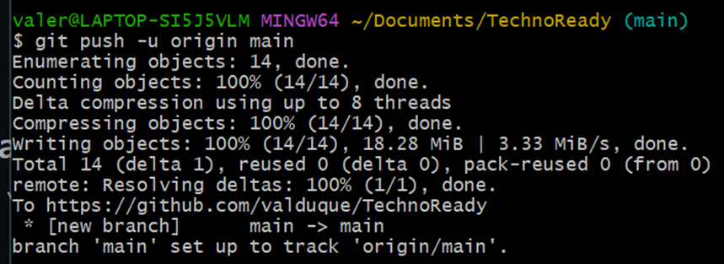
The just write the command git push origin branch.name:

And now the project appears inside the repository on GitHub:
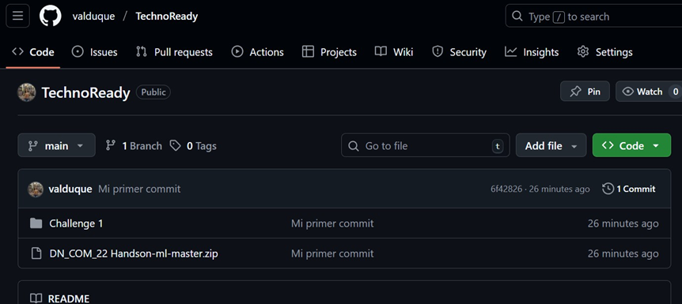

NEW BRANCH CREATION :

Inside your project, write the command git branch name.brach:

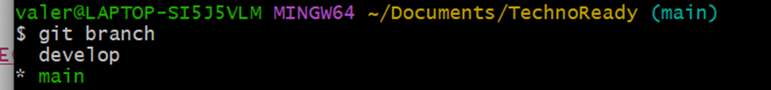
To confirm the branch creation, just write the command git branch:

1. Update to the requirements.txt file:

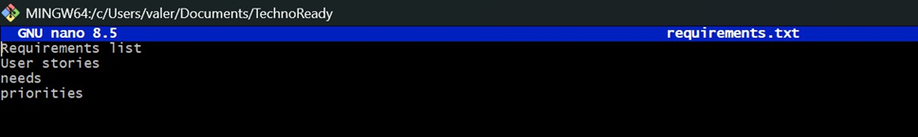
If there is ever a desire to update something, there are some rules that must be followed. First, make the desired changes in your file:

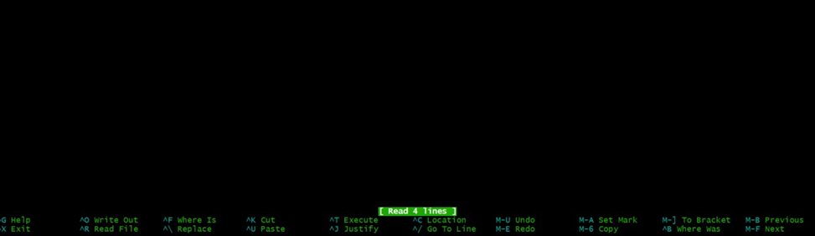
Then, save the changes with the combinations in the console below:

Once the changes have been done, you can upload them with a push to the desired branch.

CREATED PR :
If there is content uploaded that must be reviewed by other collaborators, it’s possible to create a PR to make the whole team to be on the same page or at least, on the same code.
To do this, it must be already committed and pushed to the branch. Once it’s done, in the project’s menu should appear an option to create a pull request, it shall be clicked on the “create pull request” button:
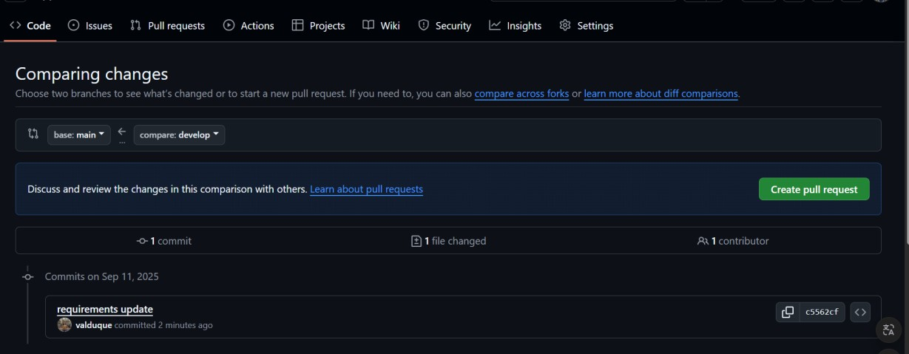

It will be able to show the changes:
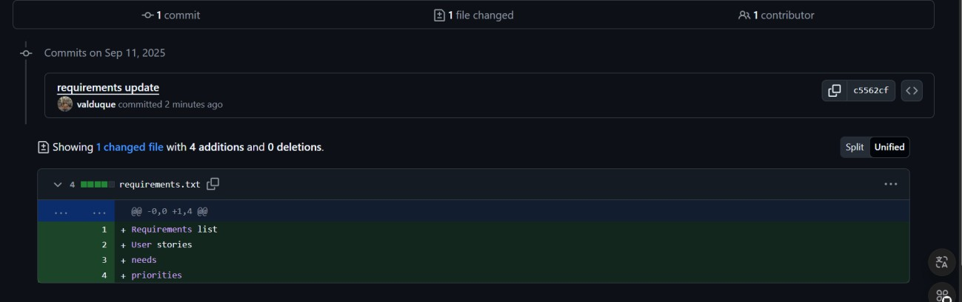

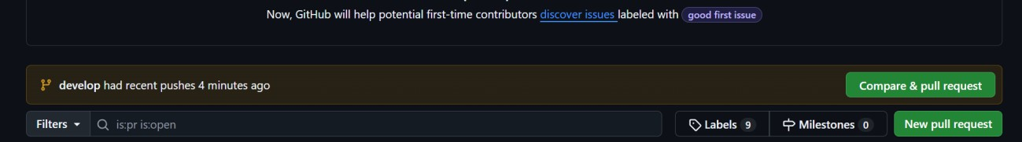
And now, it’s possible to compare and do the pull request:

It can be added descriptions and comments:
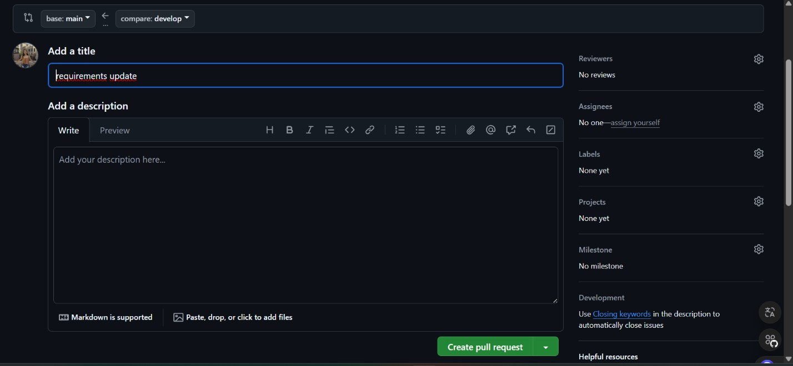

PR APPROVAL IN GITHUB:
If a pull request is done on the project, a collaborator can approve another collaborator’s work to be added to the project. The GitHub system will show if there is any conflict with the branch, or if it’s not possible to merge with the new work. In this case, it’s possible:
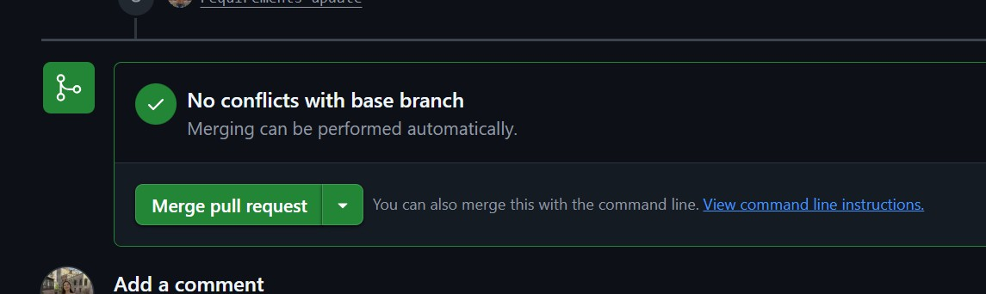

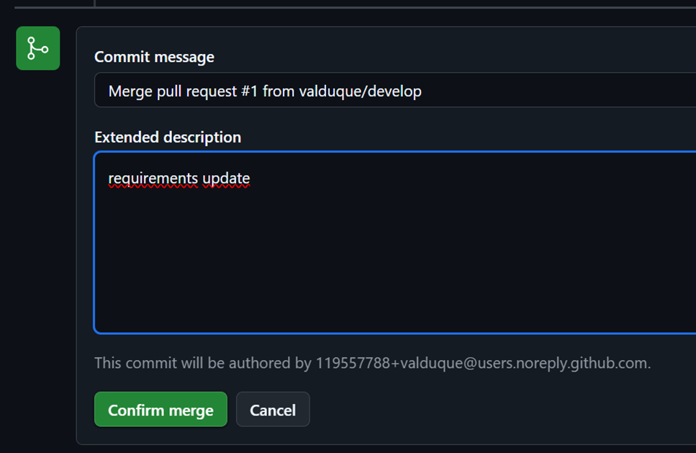
It must be clicked the “merge pull request” button and add any commentary if needed:

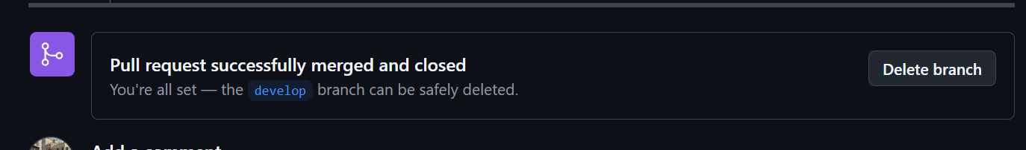
Lastly, the system will confirm that the action is finished successfully:

Creation of branch "A" from "Main":

From branch Main we just must write the command “git branch name.branch” in this case the branch will be called “A”:

Then, switch to the new branch with the command “git checkout branch.name”:

2. Creation of docs.txt in branch "A":
Inside the desired branch, write down the command “touch name_file.txt”:

Add a few lines with the command “nano name_file.txt”:

Add, commit and push all the changes with the command “git push -u origin A”:
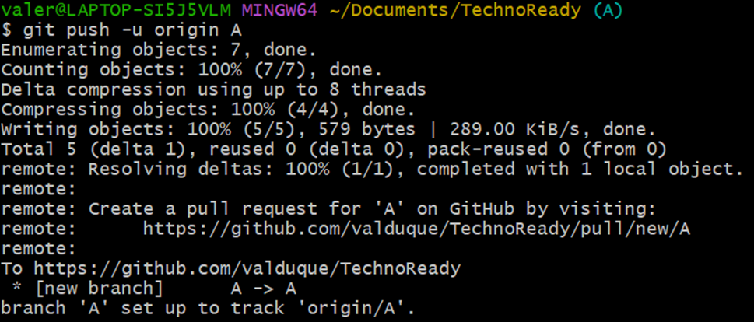

3. PR created for branch "A":
On the project’s Github repository page, it will show the new branch and pushes created by it. “Comapre and pull request” will be clicked:
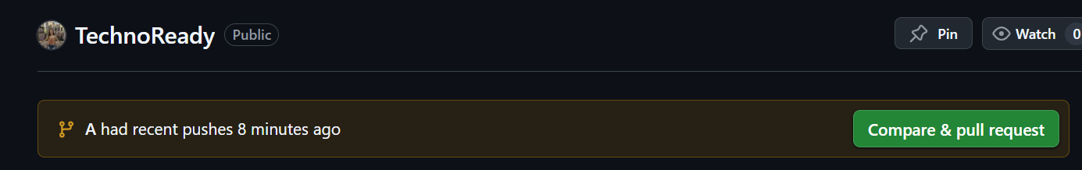

Then, the customizable page for the pull request will appear:
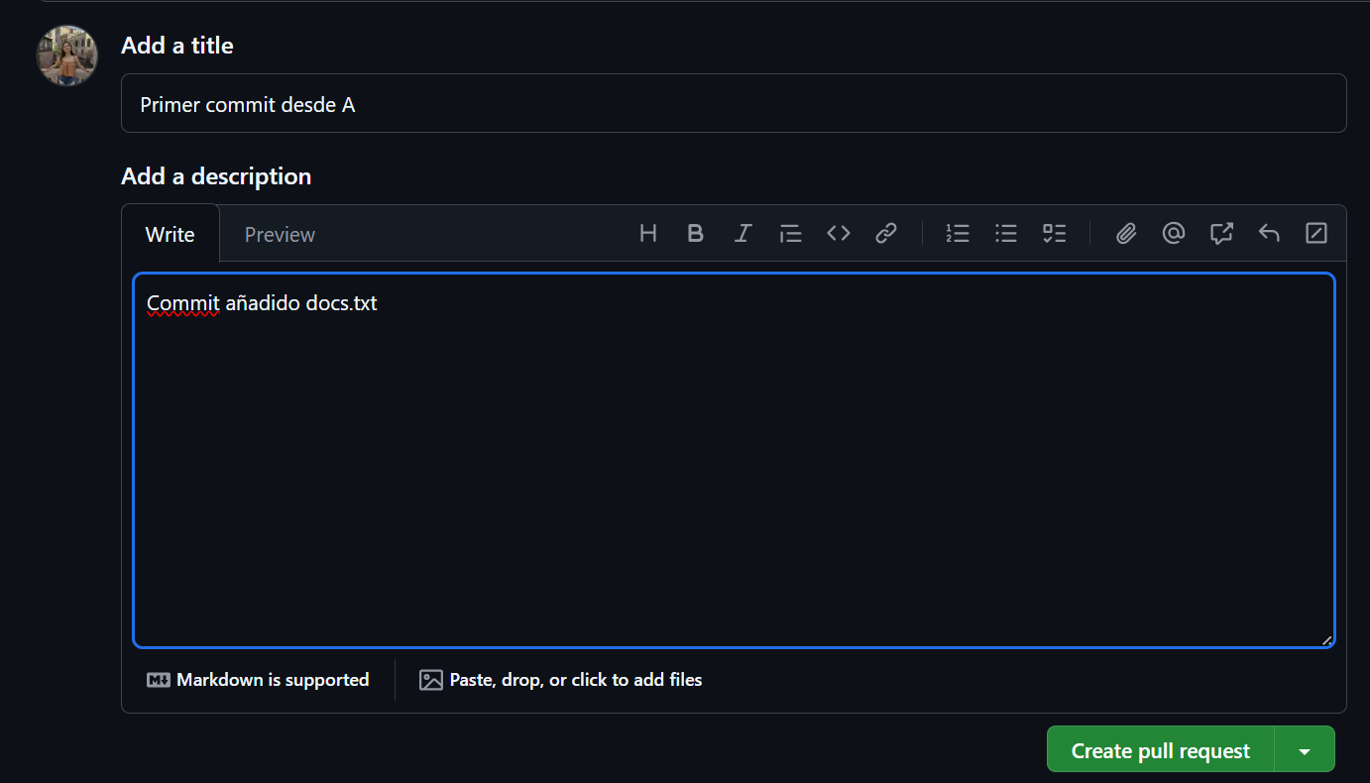

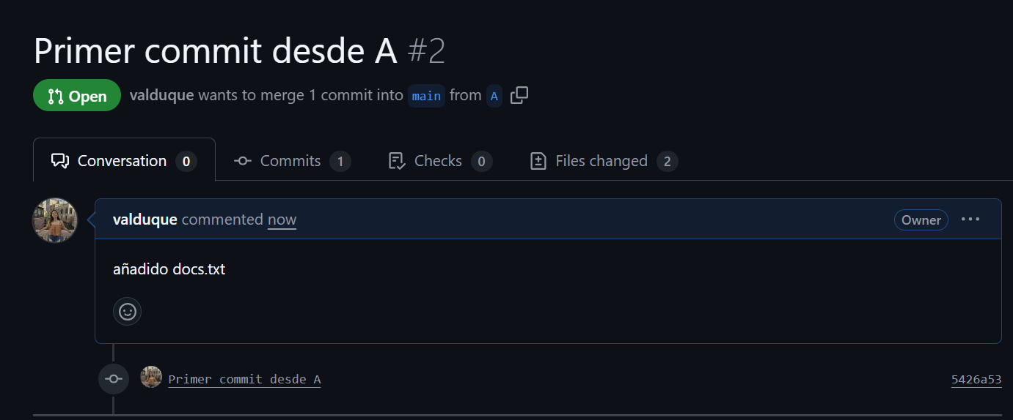
Once finished all the details, just press “create pull request”:

Creation of branch "B" from "Main":

From branch Main we just must write the command “git branch name.branch” in this case the branch will be called “B”:

Then, switch to the new branch with the command “git checkout branch.name”:

4. Creation of a different docs.txt in branch "B":
Inside the desired branch, write down the command “touch name_file.txt”:

Add a few lines with the command “nano name_file.txt”:
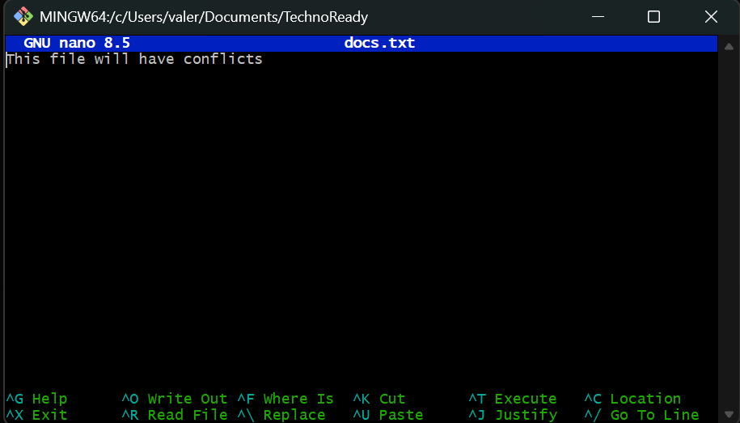
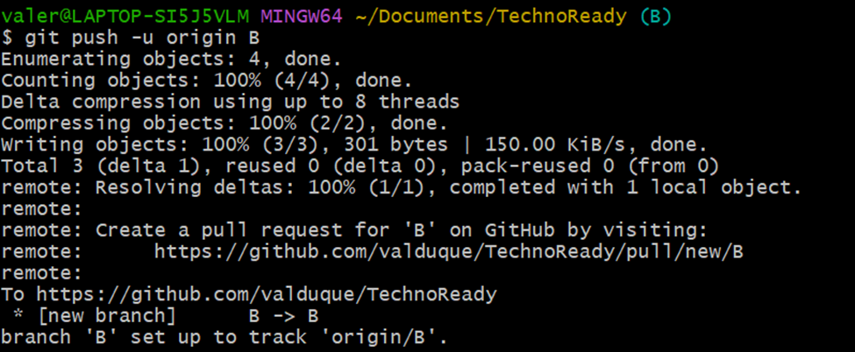
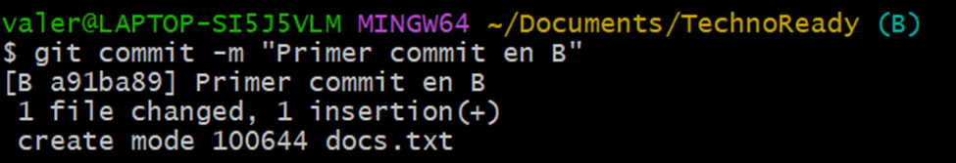
Add, commit and push all the changes with the command “git push -u origin A”:

5. PR created for branch "B":
On the project’s Github repository page, it will show the new branch and pushes created by it. “Comapre and pull request” will be clicked:
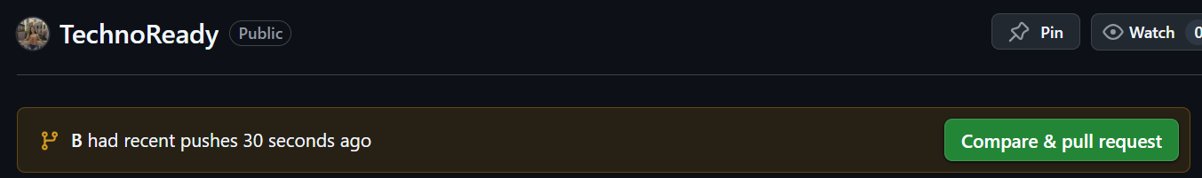

Then, the customizable page for the pull request will appear:
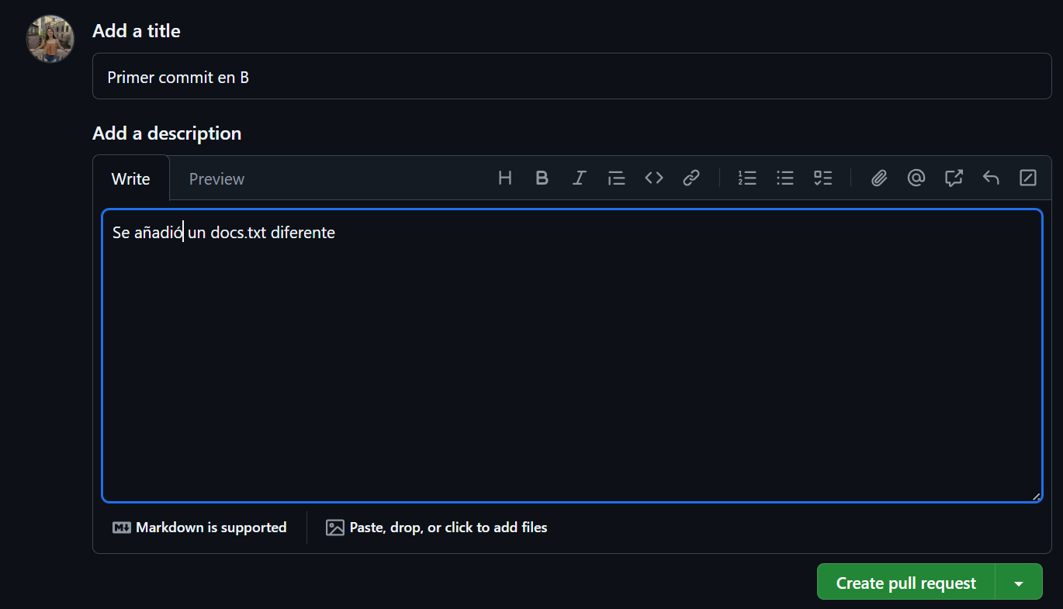

Once finished all the details, just press “create pull request”:
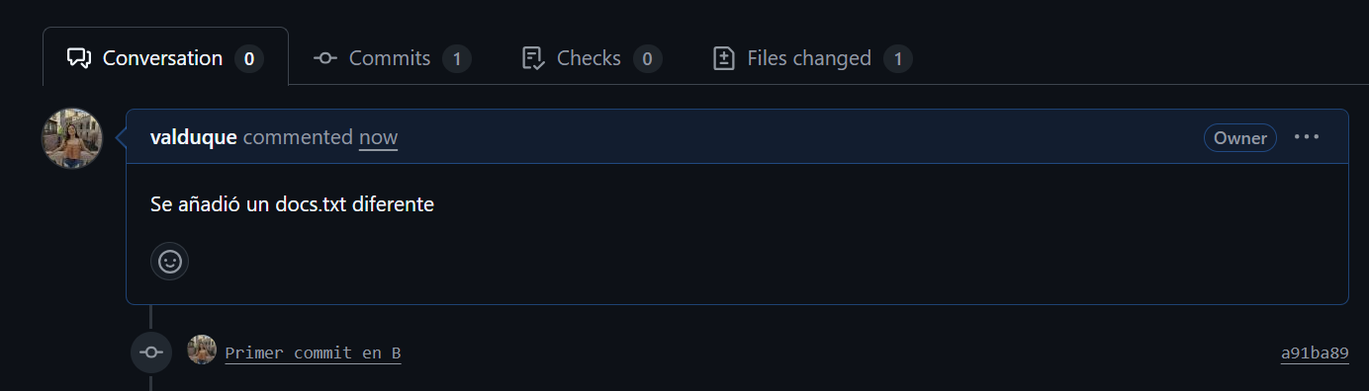

CONFLICT BETWEEN BRANCHES:

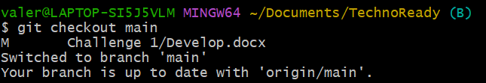
When we want to merge both branches, the creation of docs.txt, will bring up problems. First, let’s go to the main branch:

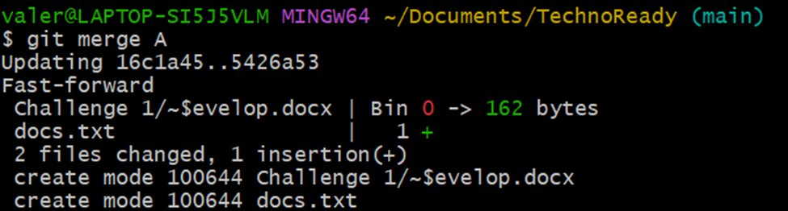
In main branch, let’s merge with the A branch with main branch:

Then, merge the B branch with the main, to get the conflict:
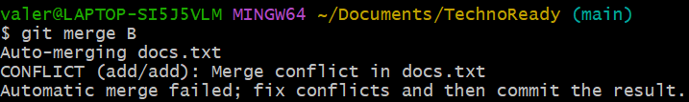

When this message It’s showed, that means we are having a conflict between branches:


CONFLICT RESOLUTION PROCESS:

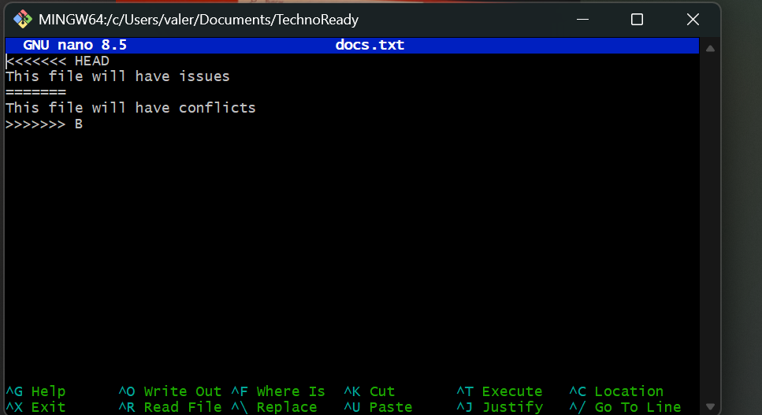
We face a challenge with the docs.txt, since now it has conflict:

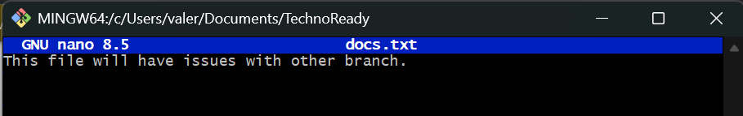
For this exercise, it was chosen to make the changes manually:

GIT COMMAND USED TO REVERT CHANGES:
Once the changes are made. We finish the merge:
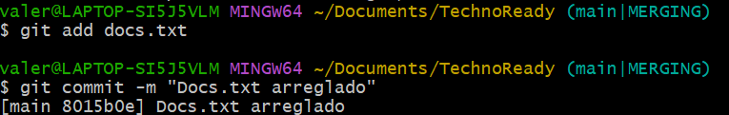

APPROVED PRS AND MERGED BRANCHES:

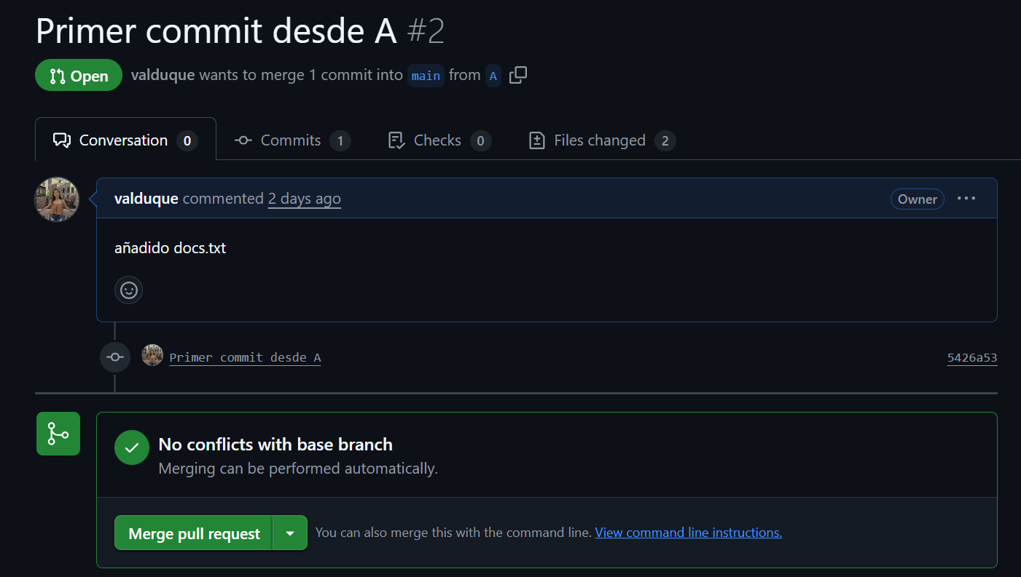
Now, we can approve the pull request for both branches, in GitHub:

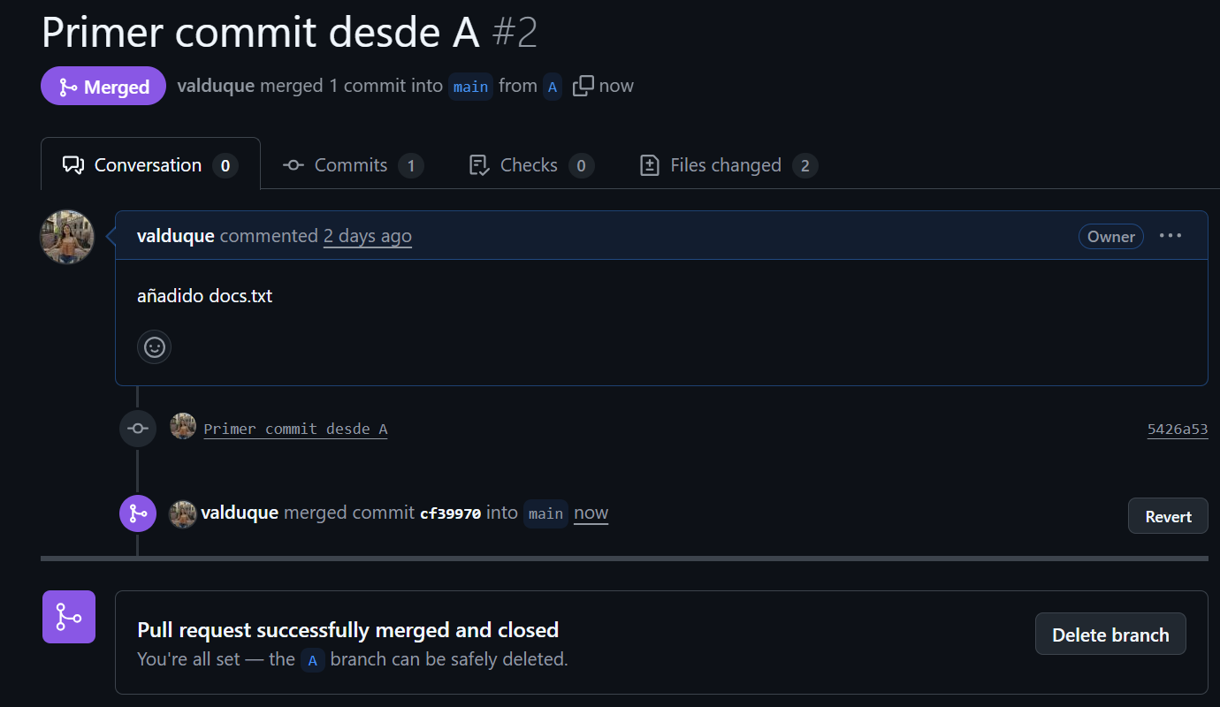
And everything is correct and working fine:

6. Pull request the other branch:
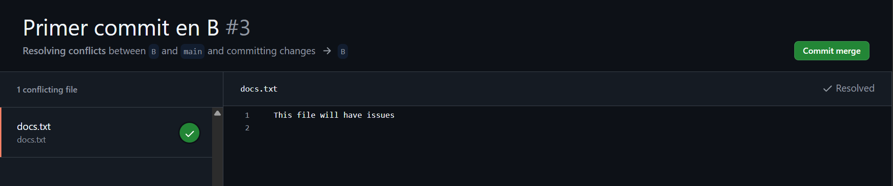
The other branch may or may not require you to fix the conflicted file. If you have to solve it just do it manually again on GitHub:


Then commit the merge:

And if there is not any issue, merge again:


